**Week 3- Task**

**Task 1**

For the task 1, we were required to download Git Bash from the given link and install it. After that we created a folder named ”L3” and right click on it to select bash here. First, I checked the git version with git –version code and added 3 files into the L3 folder.

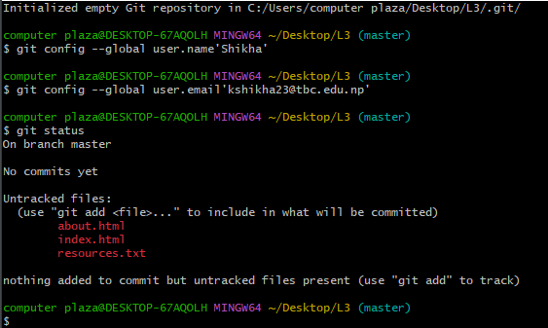

Second, I wrote some line of codes to index.html again added my name on resources.txt. After that I configured my name and mail address. Then checked the status, added files and commit changes.